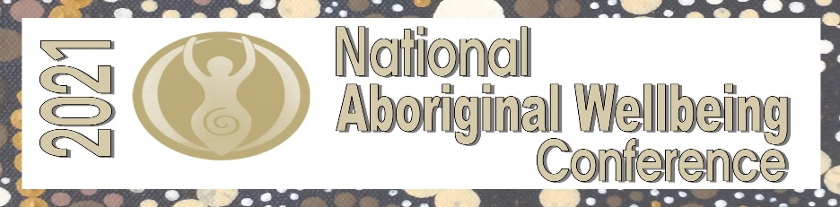

WORKSHOP
Expression of Interest
MUST BE SUBMITTED BY 20 August 2021

Speaker details
Name -
Organisation -
Contact phone number –
Email address –

Speaker bio
Speaker Bio (100 words)

Topic details
Name of keynote address -
Describe the topic – (150 words)

Proposal commitment
Do you agree to the following – YES / NO
In submitting a proposal, you are committing to meeting the NAWC deadlines, including:
Free registration will be offered to ONE presenter only – Travel, meals and accommodation are at the cost of the presenter
•Finalising all workshop details in time for the marketing of the conference by 17 Sept 2021
•Submission of workshop presentations by 29 Oct 2021
•Possible peer review where required.

Signature Date
_______________________________________________ ___________________________

Please visit www.aboriginalwellbeingconference.com
Or
Contact Mel Brown – mel@spiritdreaming.com.au
Ph – 0418 477 093

